Photo Examples & Suggestions
Getting your photos right “in-camera” will mean less work for you in the long run. It will help eliminate extra picture handling, ensure fewer rejections, and help your employees get their Identification Cards sooner.
Acceptable Photo
 | Photo meets all ETC upload requirements.  - Must be framed with full face, eyes open.  - Must include full head from top of hair to bottom of the chin and centered in the frame.  - No caps, hats, or sunglasses.  - Eyeglasses without dark tint may be worn if normally worn.  - Photograph against standard blue background furnished by ETC.  - Lighting must allow details of the face to be clearly discernible.  - No shadows on face or background.  - Natural expression.  - Must be clearly focused.  - Use the highest resolution possible.  - Do not retouch or enhance photos.  - Final photo should be 300 x 300 pixels and measure 1” x 1”.  - All photos must be in JPEG (.jpg) format.

Unaccpetable Photos
Head Too Big | Crop the head size to allow the blue background to show on top and sides.
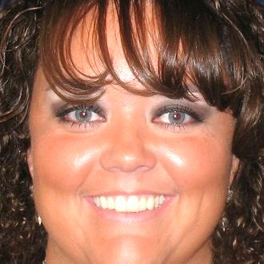
Head Too Small | Bring the shot in as close as possible. From top of hair to bottom of chin.
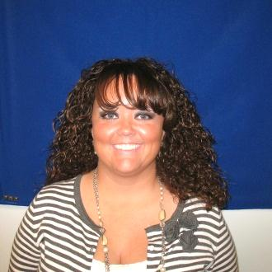
Not Centered | Full face view, centered in frame.
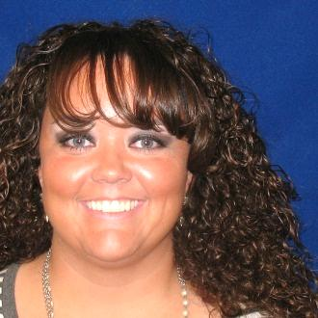
Contrast Too High
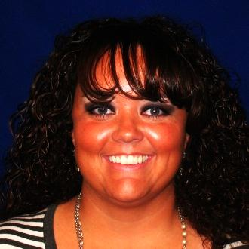
Improper Color | Overhead lighting produces different color casts. Use a flash on all photos.

Over Exposed | Too much flash back camera away from subject and zoom in.
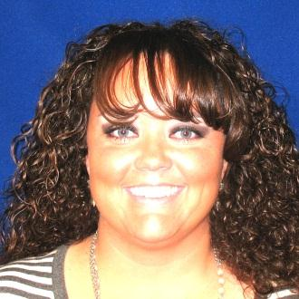

Under Exposed | Flash too far from subject. Move camera closer.

Shadows on Background | Move subject farther from background if possible. Light the background with separate light.
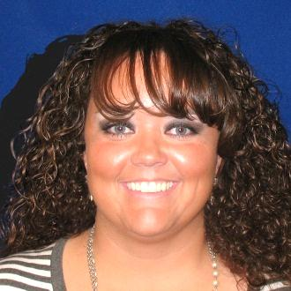
Shadows on Face | Remove possible obstructions. Add extra lights.

Low Resolution | Use correct resolution setting on camera.
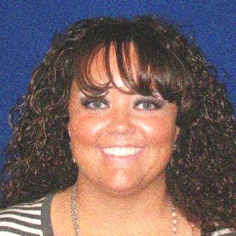

Poorly Focused | Focus on the eyes.
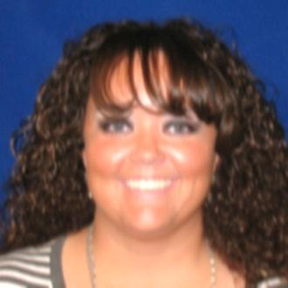
Face Distorted | Improper cropping. Be sure to crop and not adjust the photo scaling.

Eyes Closed | Eyes must be open and directed at camera.
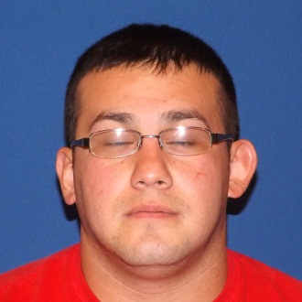
Head Covering | No head coverings, scarves, hats allowed.
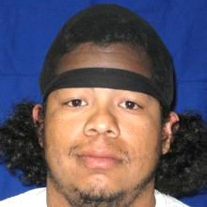

Glare on Glasses |  | Eyeglasses may be removed or tipped slightly forward to eliminate glare.

Multiple Problems | Wearing a cap, background shadows, out of focus, eyes closed, off-center, and distraction in background.
